Personal Fitness 2nd Semester 2023-24

**April 1st-5th**

**Skeletal System & Muscular System Word Search Handout**

**April 1st**

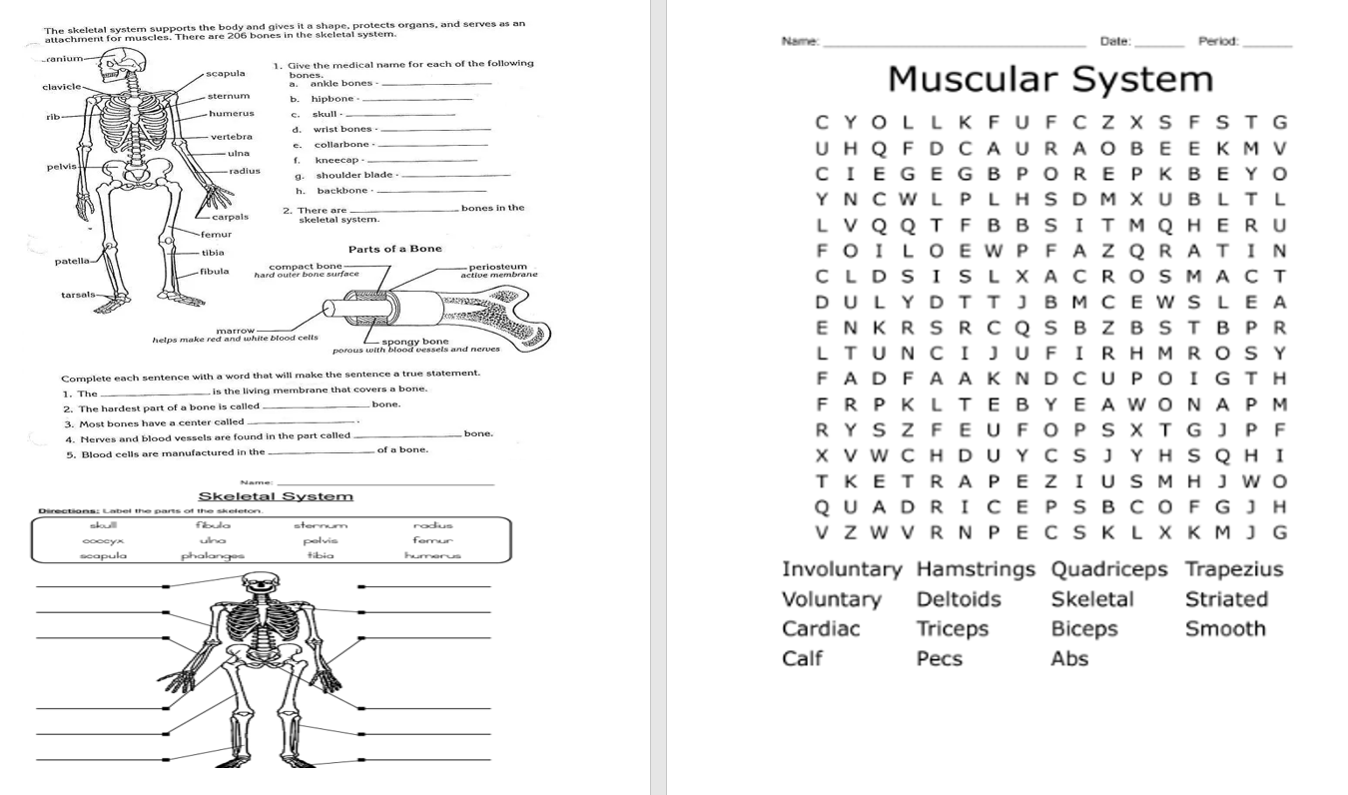

**April 2nd**

**Complete handout**

**April 3rd**

**Complete handout**

**April 4th**

**Turn in handout**

**April 5th**

**March 25th**

Makeup work

**March 26th**

Exercise with Friends Handout

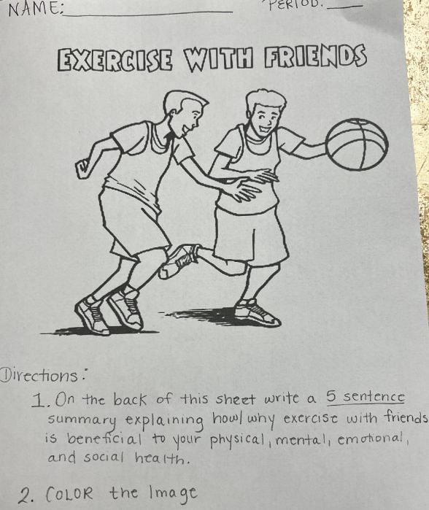

**March 27th**

Exercise with Friends Handout

**March 28th**

DUE TODAY: Exercise with Friends Handout

**March 29th**

**Good FRIDAY**

March 18th

Students work on Part C of Program Design: video

March 19th

Students work on Part C of Program Design: video

March 20th

Part C of videos due

Class Warm up

Volleyball workout (bump, set, hit line & free play)

March 21st

Class Warm up

Volleyball workout (bump, set, hit line & free play)

March 22nd

Free play

March 11th

Warm up

Basketball Workout (3 line pass & lay ups & 2 line lay ups)

March 12th

Given workbooks to use the remainder of this week and the weekend to complete missing work

-Stretch as class

March 13th

Warm up as class & Free Play

March 14th

Use time to complete Fitness Program Design Part A & B

March 15th

Free Day

Week 7

**Part A: Answer the following questions: write the questions & answer or restate question in answer**

1. List the 3 components of a workout. (use workbook information)

_____________________________ ________________________ _____________________

1. List 2 types of warmups and an example of each (specific exercises)

_____________________________________ ___________________________________

1. List 3 benefits of warming up prior to exercise
2. ________________________________________________________________________
3. ________________________________________________________________________
4. ________________________________________________________________________
5. What is a good time range for a warmup? (include the units)

_________________________________________________________

1. How is FITT used to determine one’s workout plan?

______________________________________________________________________________

______________________________________________________________________________

1. List every letter of FITT and provide a two to three-word description of each

___ ___________________________ ______________________________________________

___ ___________________________ ______________________________________________

___ ___________________________ ______________________________________________

1. List two phases of a cool down

________________________________ _________________________________________

1. List 3 benefits of proper cool down.

a___________________________________________________________________

b.__________________________________________________________________

c. __________________________________________________________________

1. Describe anaerobic exercise in your own words and provide one example______________________________________________________________________

_________________________________________Ex:_________________________________

1. Describe aerobic exercise in your own words and provide one example________________

________________________________________Ex:__________________________________

**B. Designing Your Personal Fitness Program**

**Direction: You will create a weight training SMART goal for yourself that you would like to accomplish by March 25th. Based on that goal, you will create an exercise/workout plan by using the following criteria:**

1. A 3-5minute warmup filling in all of the components of the chart. If it is not applicable, put N/A.
2. List at least 8 exercises (½ anaerobic & ½ aerobic) that you will perform for each day of your workout focusing on upper and lower body each day. You can change the exercises per day (ex. Every other day or every two days) you would just need to specify which days of the week you will be performing the exercises & draw a line down each section to separate the days. You can also just fill out another sheet.
3. Create your cool down including the two phases of a cool down and fill in the chart

**SMART Goal: For the next two weeks my strength training goal is to**_________________________

_____________________________________________________________________________________

|  |  |  |  |
| --- | --- | --- | --- |
| Warm Up | | | |
| Exercise | Sets | Reps/Time | Weight |
|  |  |  |  |
|  |  |  |  |
|  |  |  |  |
| Workout | | | |
| Exercise | Sets | Reps/Time | Weight |
| 1. |  |  |  |
| 2. |  |  |  |
| 3. |  |  |  |
| 4. |  |  |  |
| 5. |  |  |  |
| 6. |  |  |  |
| 7. |  |  |  |
| 8. |  |  |  |
|  |  |  |  |
|  |  |  |  |
| Cool Down | | | |
| Exercise | Sets | Reps/Time | Weight |
|  |  |  |  |
|  |  |  |  |
|  |  |  |  |
|  |  |  |  |

**Part C.**

Choose two of the exercises in your workout plan. For each exercise, you will do the following in your tutorial video for each exercise.

Learning Targets: I can

1. List the components of a SMART goal & FITT
2. Design & implement my own fitness plan using my SMART goal & the FITT standards.
3. **I can use the proper technique to perform exercises and identify the muscle groups that are engaged in different exercises.**

|  |  |  |
| --- | --- | --- |
| Criteria | Possible Points | Points Earned |
| 1. Introduce yourself & paraphrase learning target/s (the one in bold) | 10 |  |
| 1. Name/identify the exercise you are performing | 10 |  |
| 1. Name & include the equipment needed to perform the exercise | 10 |  |
| 1. The areas of the body that is the focus point of each exercise identifying the major muscles (2) that are engaged | 20 |  |
| 1. Demonstrate the proper technique to use breaking it down into steps | 30 |  |
| 1. Identify consequences/results that could occur from not following the proper technique | 20 |  |
| Total | 100 |  |

1. Post Video using your name with your name as the subject
   1. <https://flip.com/8bc985b1>

Feb 12

Do Now: Feb 12

Classwork: Feb 12

Feb 13

Do Now: Feb 13

Classwork: Feb 13

Feb 14

Do Now: Feb 14

Classwork: Feb 14

Feb 15

Do Now: Feb 15

Classwork: Feb 15

Feb 16

Do Now: Feb 16

Classwork: Feb 16

Week 6:

Do Now: Feb 5

1. Go to joinmyquiz.com

Classwork: Feb 5

Quizziz for review of 1st 3 lessons

Do Now: Feb 6

Login to joinmy quiz.com

Classwork: Feb 6

Quiz

Do Now: Feb 7 Warm up

Classwork: Feb 7 Fitness Stations (5 per group/ 6 groups)

* Jump rope
* Push ups
* Squats
* Lateral raises with dumbbells
* toe touches (on your back)
* high knees

Do Now: Feb 8

Classwork: Feb 8 Fitness Stations (5 per group/ 6 groups)

* Jump rope
* Push ups
* Squats
* Lateral raises with dumbbells
* toe touches (on your back)
* high knees

Do Now: Feb 9

Classwork: Feb 9

Free style Friday

Week 5:

**Jan 29**

Do Now: Jan 29

1. Complete Active Mind & Active Body page 5

Classwork: Jan 29

1. Review scores
2. Vocab KIM chart 2 on paper provided by Coach

**Fitness KIM chart 2**

|  |  |  |
| --- | --- | --- |
| **Key Term** | **Information** | **Memory Clue** |
| Example:  Functional fitness | * **Physical ability** * **On a person’s own** * **functionality** | Someone able to drive themselves places |
| 1.Cardiovascular conditioning |  |  |
| 2.Heart rate |  |  |
| 3.Maximum heart rate |  |  |
| 4.Perceived exertion |  |  |
| 5.Ratings of perceived exertion |  |  |
| 6.Talk test |  |  |
| 7.Maximum strength |  |  |

1. Tape to page 10

**Jan 30**

Do Now: Jan 30 Complete Lesson 2 review on page 12

Classwork: Jan 30 Active Mind & Body on page 9

Write the following in the blank space at the bottom of the page

1. My carotid pulse
2. My radial pulse
3. Partner’s carotid pulse
4. Partner’s radial pulse

**Jan 31:** students used this day as a makeup day for any missed assignments and reminded that Thursday the 1st of February is the last day to complete any missing work that has not been turned in.

**Feb 1:**

Warm up

Mini circuit: 2 x 8: pushups, squats, burpees, high knees, crunches

Cool down

**Feb 2: Free Day**

**Jan 8**

Do Now:

1. Staple your packet (3x down the side) as shown by coach
2. Pass the stapler back & up until the last person has done it
3. Write your first & last name
   1. On top of front page of packet (nice & big)
   2. At the bottom of page 89
   3. At the top of page 257
   4. On the bottom of the back page
4. Number pages on top right hand corner

Classwork:

1. Static & Dynamic stretching as a class
2. Free Play

**Jan 9th:** Asynchronous Learning

**Jan 10th**

Do Now: same as Jan 8

Classwork:

* 1. Coach review & have students write on page 8 & 9 what will be recorded in the gym

**Jan 11th** (Last day to turn in Asynchronous Learning Assignment and/or make corrections for more points)

Do Now: students collect notebook & get graded Asynchronous assignment

Classwork:

**Fitness KIM chart 1**

|  |  |  |
| --- | --- | --- |
| **Key Term** | **Information** | **Memory Clue** |
| Functional fitness | * **Physical ability** * **On a person’s own** * **functionality** | Someone able to drive themselves places |
| media |  |  |
| Commitment |  |  |
| adherence |  |  |
| Exercise prescription |  |  |
| frequency |  |  |
| intensity |  |  |
| time |  |  |
| type |  |  |

Ideal but not done yet due to students talking

**Jan 16**

**Do Now: On page 10 of fitness packet**

1. **Use the information from the reading. For each level/box on page 10, draw an emoji to represent your current success (BE HONEST) with the physical activity goals.**

**-definitely meet this**

**-a little**

**-not at all**

**Classwork:**

1. **Review Do Now & share out how**
2. **Read pages 3-5 (from our numbering done in class) & complete 2 Reading checks** 
   1. **on page 4 us one sentence for the first reading check**
   2. **On page 5, use 3 sentences for the second reading check**
      1. **1 to define each**
      2. **1 to provide a little more detail for each**
      3. **1 example of each**
3. **Complete fitness check on page 1 & 2 with a partner and record information according to coach’s instructions**

**Jan 22**

Do Now: review of FITT principle and exercise prescription as a class

Classwork: Complete push up & wall sits fitness check in gym

**Jan 23**

**Do Now: Get white paper with workbook**

**Class work: Exercise Prescription Factors Organizer**

**Cover Page: Heading/Title, name, period, relevant image**

**For each section include the following**

1. **Appropriate factor letter**
2. **The term the letter represents underlined**
3. **Description of the term**
4. **2 examples of what the term means**
5. **A relevant image**

**When complete, tape on page 6 as instructed by Coach & turn in workbook**

**Jan 24: Gym -review of FITT & warmup**

**Jan 25: Gym-warm up**

**Jan 26: Gym-free**

Jan 10 -12 Gym time

1. Warm up a class
2. Fitness circuits (free day after 5 minute walk on Friday)

Week 3 (2nd full week)

Jan 17-19

Warmup

Volleyball warmup & practice different hits

Game play & free time if time permits

Week 4

Do Now: Jan 22

Create foldable for fit organizer

Classwork:

1. Read & review as class
2. Complete foldable